

**Green University of Bangladesh**

**Department of Computer Science and Engineering (CSE)**

**Semester: (Spring, Year:2024), B.Sc. in CSE (Day)**

**Lab Report NO #01**

**Course Title: Database System Lab**

**Course Code: CSE 210 Section: 221 D1**

**Lab Experiment Name: Managing MySQL Databases and Tables in MySQL.**

**Student Details**

| **Name** | | **ID** |
| --- | --- | --- |
| **1.** | Tanvir Ahmed | 221002461 |

**Lab Date : 4/3/2024**

**Submission Date : 11/3/2024**

**Course Teacher’s Name : Dr. Faiz Al Faisal**

| **Lab Report Status**  **Marks: ………………………………… Signature:.....................**  **Comments:.............................................. Date:..............................** |
| --- |

**1. TITLE OF THE LAB REPORT EXPERIMENT**

Managing MySQL Databases and Tables in MySQL.

**2. OBJECTIVES/AIM**

* To create a database
* To create a table in the database
* To insert data into the table
* To describe the table
* Browse each table

**3. PROCEDURE**

1. At first, we created a database called Company.
2. Then we create a table named Employee with 5 columns.
3. We insert some employee's information into the table.
4. We show all the information from the table.
5. After that, we show all the information again with the different column names.

**4. IMPLEMENTATION**

Source Code:

1. Creating a Database:

CREATE DATABASE Company;

1. Creating a Table:

USE Company;

CREATE TABLE Employees(Name varchar(20), Age int, PhoneNumber varchar(15), Designation varchar(30), Salary int);

1. To describe the table:

USE Company;

DESC Employees;

1. Inserting some data into the Table:

USE Company;

INSERT INTO Employees (`Name`, `Age`, `PhoneNumber`, `Designation`, `Salary`) VALUES('Sophia', 30, '+8801712345678', 'Marketing Manager', 30000);

INSERT INTO Employees (`Name`, `Age`, `PhoneNumber`, `Designation`, `Salary`) VALUES('William', 48, '+8801787654321', 'Software Engineer', 40000);

INSERT INTO Employees (`Name`, `Age`, `PhoneNumber`, `Designation`, `Salary`) VALUES('Noah', 36, '+8801703647283', 'Accountant', 35000);

INSERT INTO Employees (`Name`, `Age`, `PhoneNumber`, `Designation`, `Salary`) VALUES('David ', 39, '+8801784568392', 'Data Analyst', 50000);

INSERT INTO Employees (`Name`, `Age`, `PhoneNumber`, `Designation`, `Salary`) VALUES('Evelyn', 38, '+8801738594738', 'Graphic Designer', 45000);

INSERT INTO Employees (`Name`, `Age`, `PhoneNumber`, `Designation`, `Salary`) VALUES('Chloe', 42, '+8801748592746', 'Content Writer', 40000);

INSERT INTO Employees (`Name`, `Age`, `PhoneNumber`, `Designation`, `Salary`) VALUES('Ethan', 40, '+8801797348397', 'Project Manager', 40000);

1. To see all the information in the ‘Employees’ table:

USE Company;

SELECT * FROM Employees;

1. Changing the column names and see all the information in the ‘Employee’ table (Here the actual column name doesn’t change. It just show the information with the changed column names.):

USE Company;

SELECT Name AS 'Names', Age AS 'Ages', PhoneNumber AS 'Numbers', Designation AS 'Title', Salary AS 'Salary(tk)' FROM Employees;

**5. TEST RESULT / OUTPUT**

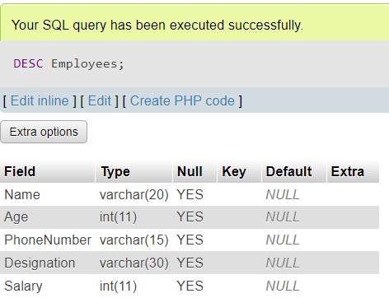

fig1. Describing the table ‘Employee’.

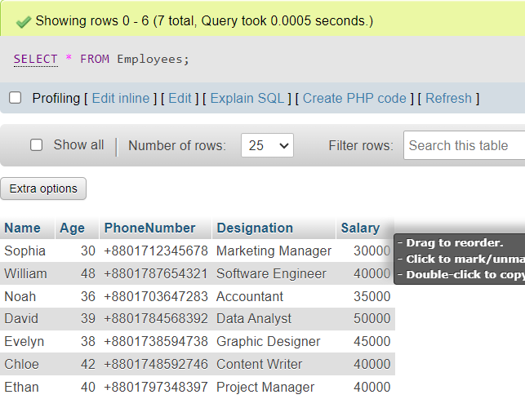

fig2. Here is all the information in the table ‘Employee’.

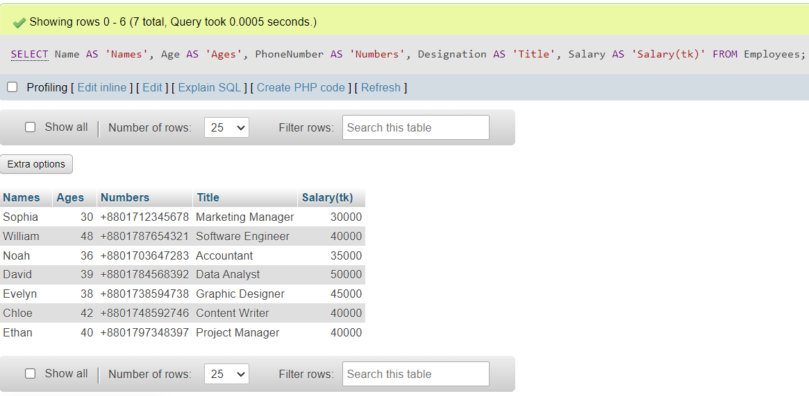

fig3. Here is all the information in the table ‘Employee’ with the given column name.

**6. ANALYSIS AND DISCUSSION**

* In this exercise, at first, the database called ‘Company’ was successfully created.
* Then we created a table named ‘Employees’ within the ‘Company’ database with five columns: Name, Age, PhoneNumber, Designation, and Salary.
* We insert some information into the table ‘Employees’ using INSERT INTO statements. Each entry includes details such as Name, Age, PhoneNumber, Designation, and Salary.
* We describe the table using DESC command.
* To see all information in the ‘Employees’ table we use SELECT * FROM Employees command.

**7. SUMMARY**

This lab exercise demonstrates practical applications of SQL commands to create a database, and table, insert data into the table, and browse each information. Through this exercise, I understood the importance of structured data management.